2. 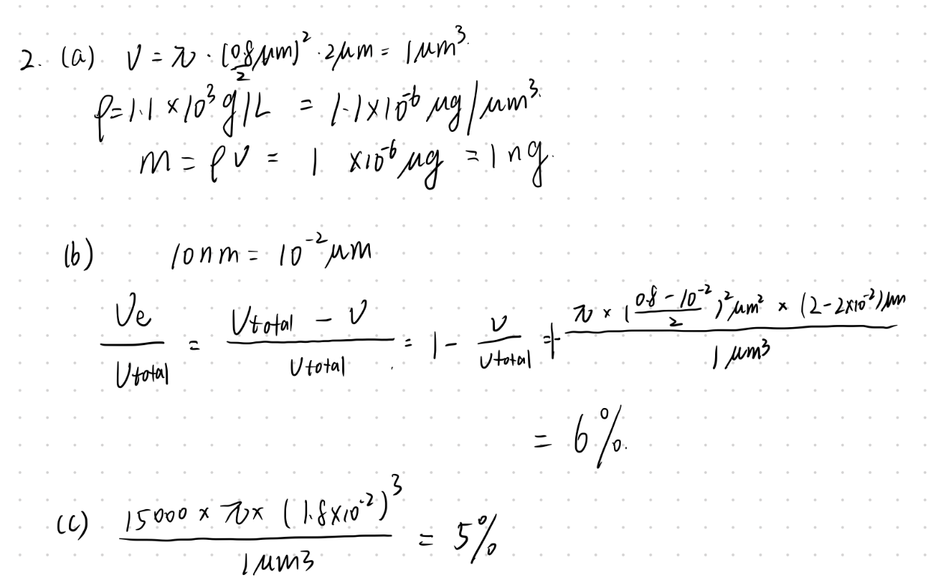

6.To my perspective, the vitamins from different sources are the same, and our body can’t distinguish them. It is because that two source of vitamins’ chemical formula and configuration have no different, so they play identical roles in biochemical reaction.

Only associated impurities might vary with the source.

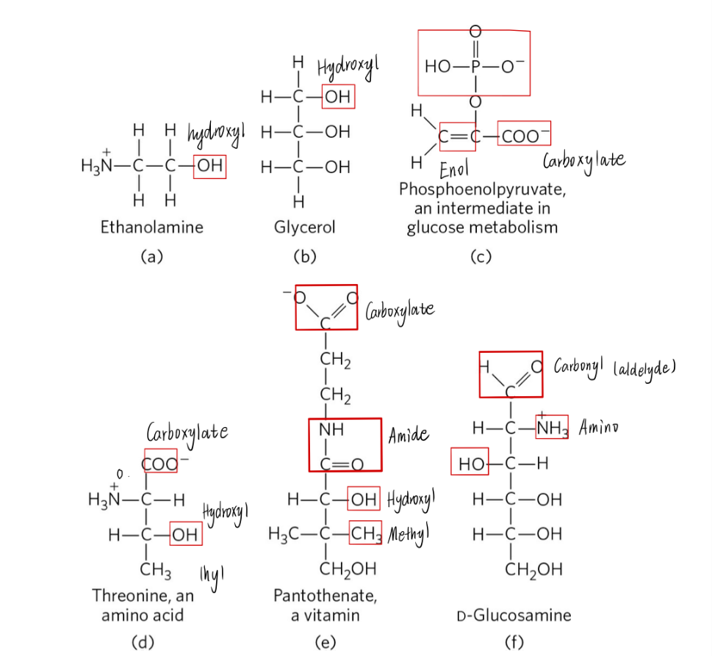7.